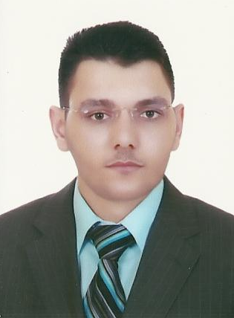
Curriculum Vitae
Amin Hassan Amin Abdelazeem

10 Gohar Elkaed St, Ard Elmahlag,
Beni-Suef, Egypt

E-mail: Amincool2008@yahoo.com

Home phone: +2 0822366592
Cell phone: +2 0109697119

PERSONAL INFORMATION:
Date of Birth: 06-03-1985
Gender: Male
Marital Status: Single
Nationality: Egyptian
Military Service: Exempted

EDUCATION:
Faculty of Commerce, Beni-Suef University, Beni-Suef, Egypt  Major: Bachelor of Commerce Minor: Accounting | 2005-2009

TRAINING:
Training at Mr. Ahmed Mahran office for accounting and consultations for two years | 2009-2011
The International Computer Driving License (ICDL)  (Windows - Word - Excel - PowerPoint – Access – Internet - IT) | 2011
Electronic Accounting certificate from German Egyptian Academy in corporation with SteinBies University, Berlin, Germany and training on three famous accounting programs:  - Accounting Excel  - Peachtree  - QuickBooks | 2011

English Accounting certificate from German Egyptian Academy in corporation with SteinBies University, Berlin, Germany  - Book Keeping | 2010
General English Course, elementary stage from AMIDEAST, Cairo, Egypt. | 2011
Diploma of accounting and management in corporation with American Walden University, German Intel Company and Egyptian ministries of industry, communications and trading | 2011
- Marketing
- Advanced Accounting Excel
- Taxes accounting
- Human resources management
- Business management
- Projects management
- Communication skills

EXPERIENCE:
Working as an accountant for Dr.Ahmed pharmacies group | 2009-Now
- Performing all accounting reports for all pharmacies
- Revision of inputs and outputs
- Dealing with all drugs distribution companies
- Taxes reports and annual accounts
- Supervision on the annual and periodic inventory
Training at Mr. Ahmed Mahran office for accounting and consultations | 2009-2011
- Training on doing the annual accounting reports for companies
- Training on taxes reports
- Inputs and outputs records and notebooks
Working at Ibn-Sina Pharm company for drugs and pharmaceutical distribution | 2010
- Working for one shift from 8 am to 2 pm
- Collecting the bills or statements from the pharmacies
- Sharing in doing the annual accounting reports
- Taxes reports preparation
- Registration of the drug returns from pharmacies
- The expire drugs inventory
- Preparation of the salaries and rewards of all workers in the company
Working at The United company for pharmacists | 2007-2008
- Training on registration of the drug returns from pharmacies
- Training on taxes reports preparation
- Training on how to do the expire drugs inventory
- Training on preparing the salaries of all workers in the company
- Training on doing the annual accounting reports
- Sharing at collecting the bills from the pharmacies
- Training on the advanced computer programs of pharmaceutical companies

SKILLS:
Language | Arabic: Fluent (Mother tongue)  English: Good
Computer knowledge | - Windows Programs  - Microsoft office with all its versions (2003, 2007, 2010)  - Computer maintenance  - Pharmacies and pharmaceutical companies programs  - Electronic accounting programs:  - Accounting Excel  - Peachtree  - QuickBooks
Car Driving | Driving license from 2004, very good in cars driving.

PERSONAL CHARACTERS

Has the capability to work under stress
- Fast enough in performing the required tasks
- Has the skill of rapid conversion and solving the sudden problems during work
- Has the ability of taking decisions in critical times
- Multi-tasking person who can do many things at the same time
- Has the ability of working in a team
- Smart, patient, precise and skillful man

REFERENCES:
Dr. Ahmed Abdelazeem | Assistant professor of Medicinal Chemistry  Faculty of Pharmacy,  Beni-Suef University  Cell phone: 002-0102877405  Email: Ahmed.pharm@yahoo.com
Mr. Mohammed Abdelrahman | Accountant, Teacher and trainer for electronic and normal accounting  Cell phone: 002-0120047350  Email: m_mekdam@yahoo.com
Mr. Ahmed Mahran | Accountant and professional trainer for electronic and normal accounting  Cell phone: 002-0103041514  Address: Salah Salem street, Beni-Suef

Note: All certificates and other documents are upon request……

