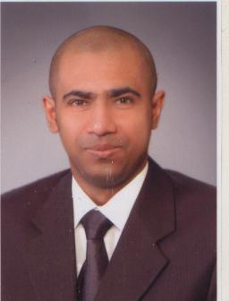
Curriculum Vitae
* Name : Mohamed Abd El Rahman Mohamed
*Birth date : June 6,1984
*Address : 1Zahret aflaton street,sha'arawy street, louran,Alexandria
*Mobile : (+2) 0128226069
*E-mail : Makaveli360@hotmail.com
*Nationality : Egyptian
*Marital status : single
*Military status : postponed
*Objective
To obtain a challenging position in a bank or a reputable company where my skills can be used and enhanced.
*Qualification
Bachelor of commerce,accounting department,English section.from Alexandria university(2008).
*Occupation History
*Has been working as an accountant for the union company for trade -Export and Import- (Abo Donkol Group).
*Had worked as a math. Teacher for modern American schoo

*Professional Certificate
Professional certificate in Bussiness Administration from The American University In Cairo (AUC) which includes :
1 | Contemporary Management | 2 | Marketing Management
3 | Human Resources management | 4 | Financial Management
5 | Organaizational behavior | 6 | Project Management
7 | Management Information System

*Computer Skills
1-professional networking course
Microsoft Certified Systems Administrator (MCSA),which includes:
1-Implementing and supporting MicroSoft Windows XP professional.
2-Managing Microsoft Windows Server 2003 Environment.
3- Maintaining Microsoft Windows Server 2003 Environment.
4-Implementing a MS Win Server 2003 network infrastructure network hosts.
5- Implementing ,Managing and maintaining a MS Win Server 2003 network infrastructure network services.

2-International Computer Driving Licence (ICDL)
^{*Microsoft Windows xp} | ^{*Microsoft Office Word}
^{*Microsoft Office power point} | ^{*Microsoft Office Excel}
^{*Microsoft Office Access} | ^{*Microsoft Office Outlook}
^{*Internet Explorer} | ^{*Information Technology (IT)}

^{3-Graphic course}
^{*Adobe Photoshop CS Certified.}
^{*Languages}
^{1-Arabic}
^{mother tongue}
^{2-English}
1-Fluent reading ,writing , spoken and Had fulfilled the requirements of the Advanced Level of courses in the English Teaching Program at AMIDEAST Alexandria.
2-Test of English for international communication (TOEIC)
^{*special skills}
^{*Decent interpersonal skills.}
*Ability to work individually as well as within a team.
^{*Self and fast learning.}
^{*self motivated.}

