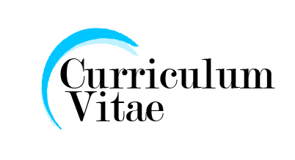
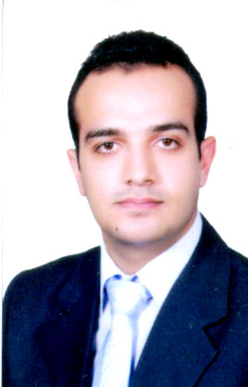
Mohamed Safwat Fahmy Khater
Kafr Shoukr - Qaluobia
Mobile : 0109517912
Home no. : 0132512404

Objectives:
Problem–Solving, self-Management , flexibility, Adaptability, Team work .

Personal data
Birth date : 15/10/1987
Religion : Muslim.
Nationality : Egyptian.
Military service : Exempted
Marital Status : Single
Education and qualifications:

Benha University - faculty of commerce 2010
Department : Accounting

Languages:

Arabic : Mother Tongue
English : Good command of both written and spoken.

Certificates:
- ICDL Computer (windows - Word – Excel – Power point – access – internet – It )
- Intel's certificate in technology and communication
- Certificate Re. Self. Improvement through PH & MC and NLP
- Training in a company in the Suez Canal Insurance
- Certificate of work experience in the company of Ben Silaik customs clearance
- Training National Bank Branch Kafr Shoukr
- Certificate yes I can to deal with tourists from the Hotel Radisson SAS

