
haitham fady elsayed mohammed
Address : Menya El kamh , Sharqya , Egypt
Primary Mobile : +2 0120333556
Secondary Mobile : +2 0147538388
Home Phone : +2 055 3390425
E-mail: haithamfady@yahoo.com

objective
- Seeking a challenging position as a Senior Accountant where I can utilize my knowledge and possess good management and supervisory skills in a company that will give me the opportunity for professional growth . I see my self as an Accountant involved in Accounting & Administration because I feel my self into this type of activity.

education
- 2000-2004 Zagazig University Sharqya , Egypt
- Faculty of Commerce , Bachelor's degree , Accounting.

Experience
- Shabakat Natural Gas (Shabakat) , Mokattam , Cairo , Egypt.

Date : 06/ 2010 - Up to date
Job title: Senior Accountant.
Duties : Responsible for the following
- Prepare regular reports and summaries of accounting activities.
- Supervision the customer accounts.
- Set the monthly collection targets for the collectors and Follow up the collector teams.
- Supervision for follow up & finish the all of the customer complaints.
- closing of the accounts daily and monthly branch.
- Preparing monthly trail balance.
- National Gas Company (NATGAS) , New Maadi , Cairo , Egypt.
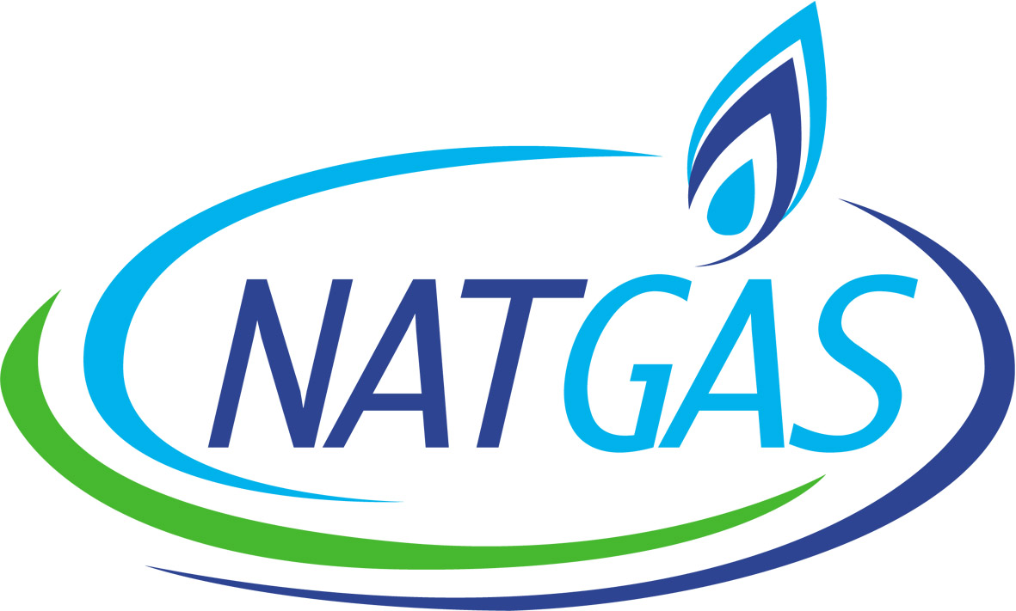
Date : 01/ 2010 - 05/2010
Job title: Senior Accountant.
Duties : Responsible for the following
- Prepare regular reports and summaries of accounting activities.
- Set the monthly collection targets for the collectors and Follow up the collector teams.
- Supervision the clients accounts in the company.
- closing of the accounts daily and monthly branch.
- Preparing monthly trail balance for clients.
- National Gas Company(NATGAS) , New Maadi , Cairo , Egypt.
Date : 06/ 2006 - 12/2009
Job title: Accountant.
Duties : Responsible for the following
- Recording daily entries in the sub journals and general journal .
- Posting entries to sub ledgers and general ledger.
- Maintained all aspects of finance, accounting, and data processing for the company.
- Preparing monthly trail balance.

courses
- Effective Writing Techniques for Business Reports from "APROMAC".
- Courses in Microsoft Excel from Syndicate of Commercial Professions.
- Courses in English from Language Institute of the Armed Forces"MODLI".

Key Strengths
- Communication Skill:
- Good experience in conflict management and stress management .
- Ability to interact with others with tact and diplomacy.
- Professionalism in dealing with confidential information.

- Organized:
Very organized in my task and responsibilities assigned to me. This helps me to do my work effectively
and efficiently.

- Language Skills:
- Native language Arabic.
- Good command of both written and spoken English.

- Computer Skills:
- Highly proficient with computer applications and Advanced user of Microsoft Programs .
- Good knowledge of basic operating system like Microsoft Excel,Word,Power Point and Internet tools.
- Knowledge in the use of financial software applications, spreadsheets, and word processing required.

- Other Skills:
- Excellent report writing skills.
- Able to learn new tasks quickly, enhance knowledge always.
- Good statistical and analytical skills .
- Directed a team of accountants to increase accuracy and reduce time for financial recording and reporting.

INTeRESTS
- Computer, Internet, Reading.

Personal Information
- Date of Birth : 24/03/1984
- Marital Status : Single
- Military Status : Exemption
- Religion : Muslim

References:Furnished upon request
haitham fady.

