It has been found that in a small town number of uneducated people is decrease each year by 40% of the previous year.
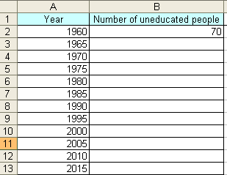

- Set up a spreadsheet that represents the above table.
(1 mark)

- Calculate number of uneducated people in the town till year 2015.
(2 marks)

- You will have some numbers with decimal points. Are they realistic? Why?
(1 mark)
Yes, they are realistic.
- Show calculated numbers in two decimal places.
(1 mark)
0.28
- Create a column chart showing the decrease in number of uneducated people (the x-axis represents the years).
(3 marks)

- Take into account the following chart options.
    - Suitable chart title, x-axis tile and category y-axis title.
(3 marks)
    - Chart location in a new sheet named "uneducated people chart"
(2 marks)
    - Check the "logarithmic scale"
(1 mark)
    - Let the x-axis start from 0.1
(1 mark)

- In your opinion, what do numbers of uneducated people of years 2005 ... 2015 mean?

