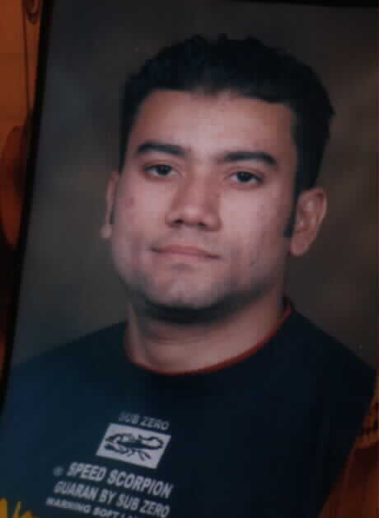 Ahmed Mohamed Ahmed GhazaL
2Ibrahim Shehata Street, El-Malek Faisal
Giza, Egypt
Telephone: 33848351
Mobile: 0103718348
E-mail: elcoachh@yahoo.com
objective
Seeking a position in the field of accounting where my skills and education are utilized and developed.

education
2000-2004 Cairo University Cairo, Egypt

- Faculty of commerce
- Grade: Good

skills
Computer skills:
- Good knowledge of M.S office
- Good knowledge of internet

Language Skills:
- Native language Arabic
- Good command of both written and spoken English
Experience
- Mar08 till now accountant in Elandalos group for trading & industry in Elharam st , Giza.
- Jul06-Feb08 accountant in Elkods for trading & agencies in Faisal st , Giza.
- Jun05-Jul06 accountant in Bedaya Company in 6 ^{th} October City
- Aug04-nov04 basic business Skills Acquisition (BBSA) Cairo, Egypt
Sponsored by the Future Generation Foundation (FGF)
And Training
- Developed Language and Computer skills
- Enhanced Presentation & project development skills
Acquired basic business skills including: marketing, sales, banking, accounting and business correspondence.

Interests
Working out in the gym, football, reading
Personal Information
Date of Birth: 14/11/1981
Marital Status: Single
Military Status: Exempted

