
Abdelkader Ahmed Abdelkader
44 horeya st imbaba
Tel. : 3116136 M : 0103724212
E-Mai : kader6000@yahoo.com or kader6000@gmail.com

Personal Information's:
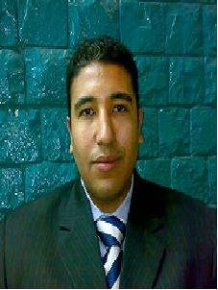
- Name : Abdelkader Ahmed Abdelkader
- Date of Birth : 23/7/1980
- Religion : Moslem
- Gender : male
- Nationality : Egyptian
- Marital Status : single
- ID No. : 2103736
- Military Status : finish it
Education:-
- Educational level : facility of commercial
- University name : Cairo university
- Grade : acceptable 60%
- Graduation Year : 2001
- Spoken Language : English
- Computer Skills : windows for all version , office2000(word .excel. power point .access . outlook. ) , internet
- I has successfully completed the Basic Business Skills Acquisition form Future Generation Foundation
Training:-
- Previous Courses :
    - Windows All Version.
    - Office [Word, Power Point, Excel, outlook, access].
    - Maintenance and Repair the Computer Programming
    - Good Knowledge about Internet.
Personal Skills:-

Assembles Computer PC's, Installing All Windows, Working on All Operating Systems Including dos , Maintenance and Repair the Computer Devices Repair a Devoid Simple Errors and Pads on Hard Disks.
I was working in proctor and gambel for 3 years form 2001 a data entry

Thank you References Are Available Upon Request

